**SUBMITTING SERVICENOW TICKETS TO KEES HELP DESK**

Once it has been determined that an issue is not worker error, an Incident should be reported to the KEES Help Desk for resolution.

If you are reporting an **outage**, please email the KEES Help Desk at [KEES.HelpDesk@ks.gov](mailto:KEES.HelpDesk@ks.gov). If the outage has occurred after 5pm or on a weekend, please email [KEES.Tier1@ks.gov](mailto:KEES.Tier1@ks.gov).

If you need assistance with your KEES, Perceptive Content, or ServiceNow password, please call 1-844-723-5337 and select option 1 -or- email [KEES.Tier1@ks.gov](mailto:KEES.Tier1@ks.gov).

For all other issues pertaining to KEES, Current™, Perceptive Content, the PE Tool, the KDHE Document Upload Portal, the Medical SSP, or the availability of the KEES User Manual, please follow these instructions to submit an Incident to the KEES Help Desk using ServiceNow.

**Submitting an Incident**

To submit an Incident in ServiceNow, click on the *Submit a New Incident* link.

ServiceNow will automatically fill in the **Number**, **Caller**, **Contact**, **Location**, **State**, and **Contact** **Type** fields.

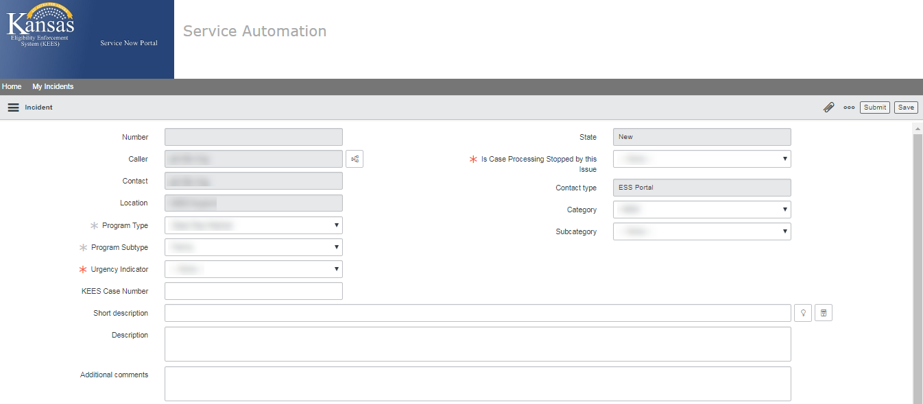

Next, you will need to select a **Category** and **Subcategory** for the issue you are reporting.

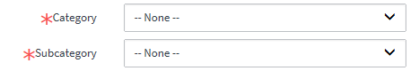

**Category**: This is the general area the issue falls into. These are the Category options:

* *Current* – Issues related to the Current™ work management tool.
* *Database Error* – **Do not use.**
* *ImageNow* - Issues related to Perceptive Content.
* *Infrastructure* – **Do not use.**
* *KEES* - Most all KEES issues fall into this category.
* *Outage* - Used for any kind of an outage.
* *Presumptive Eligibility* – Issues related to the PE Tool or the PE Program.
* *Security* – **Do not use.** Contact the Tier 1 Help Desk for login issues.
* *SSP* - Issues related to the Medical Self-Service Portal or the KDHE Document Upload Portal.
* *Reports* – Issues related to KEES Reports, AdHoc Reports, and Dashboard Reports.

**Subcategory**: This is used to capture the specific area the issue falls into. These are the Subcategory options:

Under Current

* *Dashboard Issues* – Issues with dashboard metrics.
* *KEES Mismatch* – There is a mismatch in data between Current™ and KEES.
* *Reports* – Issues related to reports either imported into Current™ or exported from Current™
* *Security Issues* – Should only be submitted to the KEES Help Desk once a supervisor has confirmed the user has the proper User Role(s) to do the required action.
* *Other* – Current™ issues not covered by another Subcategory.

Under ImageNow

* *ImageNow-Document Re-indexing Issue* – Issues related to re-indexing documents.
* *ImageNow-Functional/Policy* – **Do not use.**
* *ImageNow-INMAC Error* – **Do not use.**
* *ImageNow-Missing PDF* – Issues related to missing PDF documents.
* *ImageNow-Other* – Perceptive Content issues not covered by another Subcategory.
* *ImageNow-Unusable Image* – Issues related to unreadable images.

Under KEES

* *KEES Batch* - Issues related to the Monthly Reviews Batch (includes missing Review & IR Records or issues with the Redeter Record), Reviews Discontinuance Batch, Premium Billing Discontinuance Batch, etc.
* *KEES BOT* – Issues related to KIERA (the update address/phone number BOT)
* *KEES Contact Log & Journal* – Issues related to the Contact Log or Journal.
* *KEES Duplicate ID* – Issues related to Duplicate IDs in KEES.
* *KEES File Clearance/MPI* – Issues related to File Clearance or the Master Person Index.
* *KEES Fiscal* – **Do not use.**
* *KEES Forms Notices* - Issues related to Forms and NOAs.
* *KEES Functional/Policy* - This option should be used sparingly and only when the issue does not fit into one of the other subcategories.
* *KEES Interfaces* - Issues related to the HUB, SDX, BENDEX, EATSS, KDOL, TALX, KPERS, VLP, MMIS (includes pushing eligibility), Premium Billing Balance File (incorrect delinquency indicator or balance), AVR phone system, etc.
* *KEES Latency* – Issues related to KEES latency.
* *KEES Online Data Collection* - Issues related to any of the Financial or Non-Financial data collection pages.
* *KEES RDB* – Issues related to the Resource Databank.
* *KEES Registration* - Issues related to Reapply, Rescind, eLinking or administrative roles.
* *KEES Reports* – **Do not use.** Reports have their own Category now.
* *KEES Rules and Eligibility* - Issues related to EDBC, missing or incorrect Review Due date, CE dates, CHIP penalty period, non-compliance, etc.
* *KEES Security Permissions* – Issues related to incorrect security permissions.
* *KEES Tasks* - Issues related to tasks.

Under Outage

* *KEES Outage*
* *Address Normalization Outage* – (Address normalization tool)
* *Current™ Outage*
* *Document Upload Portal Outage*
* *ImageNow Outage*
* *Interface Outage* – (Real-time interfaces offline)
* *KEES User Manual Unavailable*
* *PE Tool Outage*
* *Provider Portal Outage* – **Do not use.**
* *Reports Outage*
* *SSP**Outage*
* *Task Outage* – (More than one worker impacted.)

Under Presumptive Eligibility

* *PE Determination (KEES)* – Issues specific to the Presumptive Eligibility program in KEES.
* *PE Tool* – Issues specific to the PE Tool.

Under Reports

* KEES Reports – Issues related to reports that are run directly from KEES.
* AdHoc Reports – Issues related specifically to AdHoc Reports.
* Dashboard Reports – Issues related to the KEES Dashboards (if it is a Current Dashboard issue, please use the Category of *Current*).

Under SSP

* *Access My Benefits Portal*
* *Document Upload Portal*
* *P-EBT FRSL Portal* – **Do not use.**
* *P-EBT Parent Portal* – **Do not use.**
* *Provider Portal* - **Do not use.**
* *Self Service Portal*
* *SSP Account Delink Request* - Requests to have SSP accounts delinked from their KEES case number.
* *SSP-Functional/Policy* - **Do not use.**

If you selected ImageNow, KEES, or Presumptive Eligibility from the Subcategory drop-down, the **Is Case Processing Stopped by this Issue** question will appear. For any scenario where you are unable to complete the determination, select *Yes* from the drop-down.



Next, you will need to select a **Program** **Type** and **Program Subtype**.

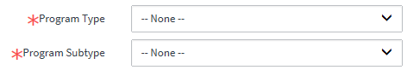

*Medical* or *Dead Stop Medical* should be selected as the Program Type. *Dead Stop Medical* should only be selected if the consumer does not have current benefits and you are unable to approve their application -or- if you are unable to rescind or reapply someone.

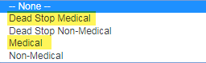

The Program Subtype is dynamic to the Program Type. Select the Program Subtype you are submitting a ticket for from the drop-down.

If you selected Dead Stop Medical in the Program Type drop-down, the **Urgency Indicator** field will appear. If your case has an urgent need, please select the appropriate indicator from the drop-down. If there is no urgent need, please select N/A in the drop-down.

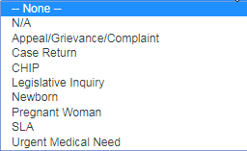

Enter the case number in the **KEES Case Number** field.



Next is the **Short Description** and **Description**:



The **Short Description** should be a short but descriptive summary of the issue you are reporting. Please be DESCRIPTIVE – do not use “KEES Issue”.

Here are some examples:

“Unable to approve PW benefits; Error received at EDBC”

“Override Needed for Rescind”

“Duplicate ID”

“Unable to complete Process Application task.”

The **Description** field should be completed by copying and pasting the body of the KEES Issue Template into the Description field. You must completely fill out the template and then it must be pasted into the Description field. **Please be as detailed as possible. Whenever you can, give the steps you took or list what actions you have already taken on the case.**

**Do not** attach the template to the ServiceNow ticket with a description of “see attached”. Highlight the entire table, then Ctrl+C to copy it. In the Description field on the Incident ticket, Ctrl+V to paste it. DO NOT INCLUDE ANY PII.

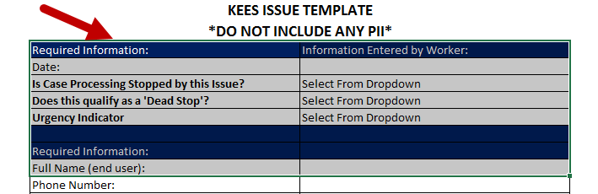

You must include a screenshot if you are reporting an error message or an issue related to a Form/NOA or a Task. When reporting an error message, you must include the date and time the error message was received and exactly what you were doing when you received it. All PII must be removed from the screenshot.

Screenshots can be attached by dragging and dropping a document anywhere onto the Incident ticket in ServiceNow. Simply locate where the document is saved on your computer, and then drag and drop a copy of the document over to ServiceNow.

Your attachments will show at the top of your ticket right above your Incident Number.

Click the Submit button once you are finished. You will receive an auto-generated email confirming your ticket has been received.

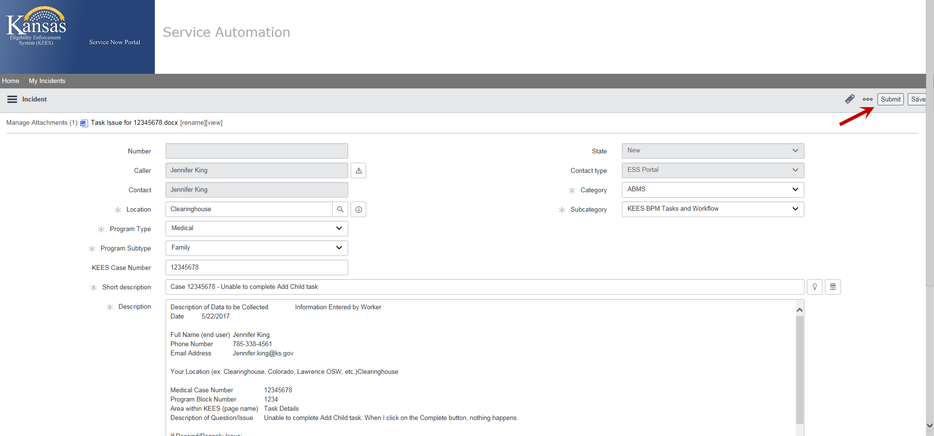

Reminder:



